## EXPERIMENT SEQUENCE

1. On MS-COCO Dataset

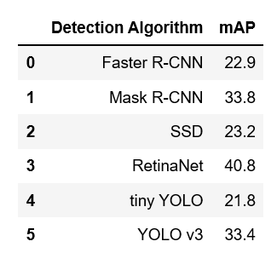

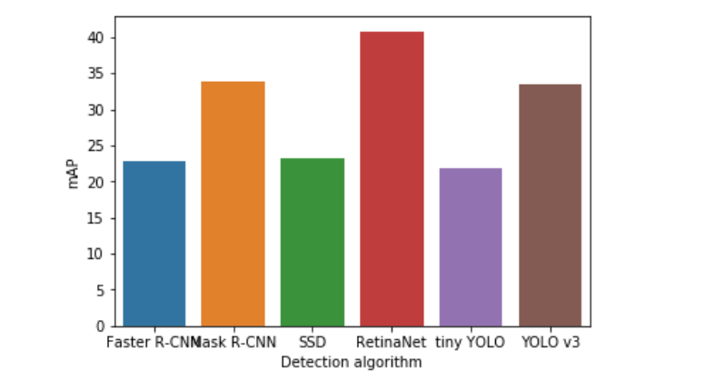

1. On KIITI Dataset

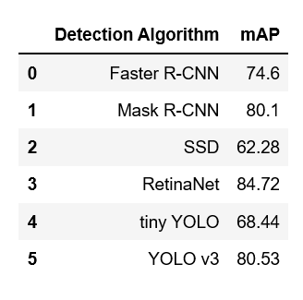

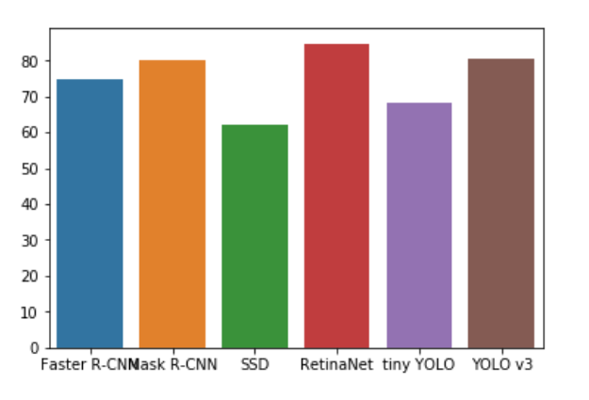

1. On Berkeley’s Deep Drive (BDD) Dataset:

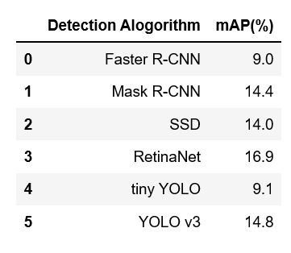

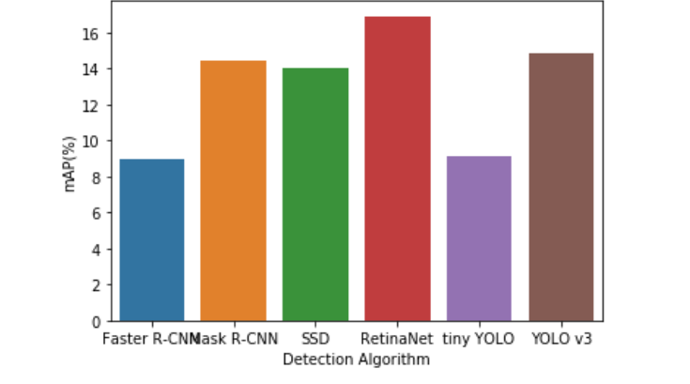

***We chose Yolo v3. Then, why we chose Yolo v3: Refer to previously submitted file***

1. We re-trained the yolov3 model to detect Indian vehicles. Model was retrained on 5 clasess, We secured descent mAP:

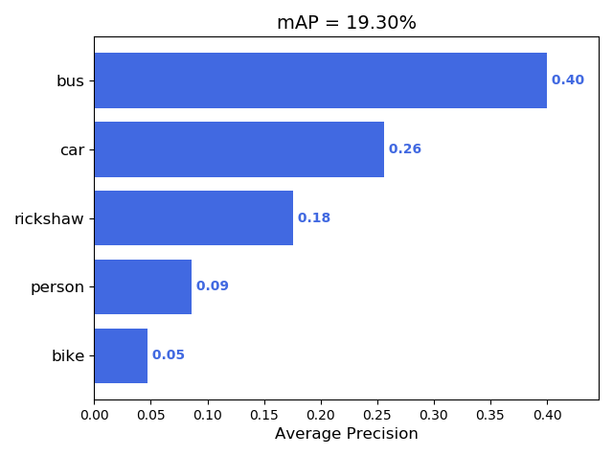

Note: you can prepare a tabular format also.